Psychophysiology Lab: Positive Gaming & Streaming (Lab assistant position)
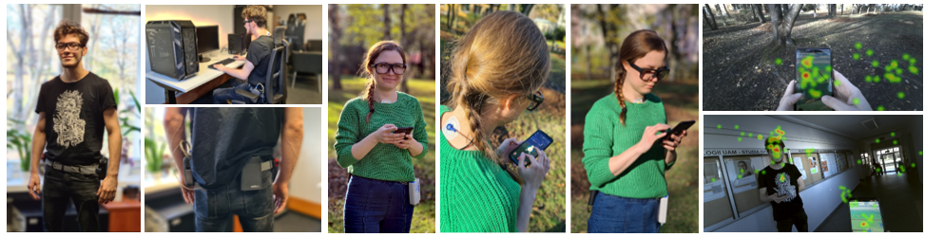
Duration: 3-6 months (duration of the internship can vary between 3 and 6 months, based on the applicant’s preferences; the beginning of the internship is flexible)
Commitment: Full-time (hybrid model 3:1: on-site work in the lab (3/4) and remote work between studies (1/4).
Description: The intern will participate in laboratory research on gaming and video game streaming, focusing on the measurement of emotions, physiological responses, and expressive behavior. Physiological signals cover peripheral physiology: electrocardiography, impedance cardiography, skin conductance, respiration, blood pressure, etc. Depending on the current project, this includes laboratory studies or field studies on mobile geolocation gaming.
Possible core responsibilities: You will participate in research projects, working under the supervision and guidance of senior researchers. Sample tasks include:
- Physiological data analysis (processing data, e.g., visual inspection and manual correction of physiological signals, data reduction by running macros)
- Behavioral data analysis (e.g., coding behaviors based on video recordings)
- Assisting in lab work, including lab equipment maintenance, participant recruitment, and scheduling.
- Collecting data from participants
- Working on review papers and meta-analyses related to gaming (literature searches)
- Depending on talent and interest, the assistant can contribute to other parts of research (writing, setting-up equipment, writing code for data analysis, etc.)
Requirements: We are looking for someone passionate about gaming psychology and experimental psychology to join and contribute to our team. An ideal candidate should present the following:
- English (B2 level)
- Good digital skills (Coding skills might be helpful but are not necessary)
- Accuracy and thoroughness
- Quick learner
- Interest in video games and video game streaming

